DEVOPS03 Project

I) LINK LAB :
https://www.youtube.com/watch?v=fAhJbFEMsos&t=853s
II) Prepare
Exam this lab , servers have IP public and private like this
+ Controller server :
Private 172.16.1.1
Public 118.69.x.x
+ Jenkins server:
Private 172.16.1.2
Public 10.70.x.x
+ Ansible server:
Private 172.16.1.3
Public 151.20.x.x

III) how to setup
1) create vpc + 3 EC2 Server (Jenkins, Ansible, Controller)
Using Terraform
2) Install package for jenkins & Ansible
Using Ansible file
3) Install kops on Controller server (172.16.1.1 - 118.69.x.x)
3.1) install kops

$ curl -LO https://github.com/kubernetes/kops/releases/download/$(curl -s https://api.github.com/repos/kubernetes/kops/releases/latest | grep tag_name | cut -d '"' -f 4)/kops-linux-amd64
$ chmod +x kops-linux-amd64
$ sudo mv kops-linux-amd64 /usr/local/bin/kops

3.2) install kubectl

$ sudo apt-get update
$ sudo apt-get install -y apt-transport-https ca-certificates curl
$ sudo curl -fsSLo /usr/share/keyrings/kubernetes-archive-keyring.gpg https://packages.cloud.google.com/apt/doc/apt-key.gpg
$ echo "deb [signed-by=/usr/share/keyrings/kubernetes-archive-keyring.gpg] https://apt.kubernetes.io/ kubernetes-xenial main" | sudo tee /etc/apt/sources.list.d/kubernetes.list
$ sudo apt-get update
$ sudo apt-get install -y kubectl

3.3) install awscli

$ sudo apt install awscli

3.4) install ssh-keygen

$ ssh-keygen

3.5) create aws s3 bucket , name devops03.in

$ aws s3 mb s3://devops03.in
$ export KOPS_STATE_STORE=s3://devops03.in # and then kops will use this location by default. We suggest putting this in your bash profile or similar.

3.6) create route53, name devops03.in , private dns

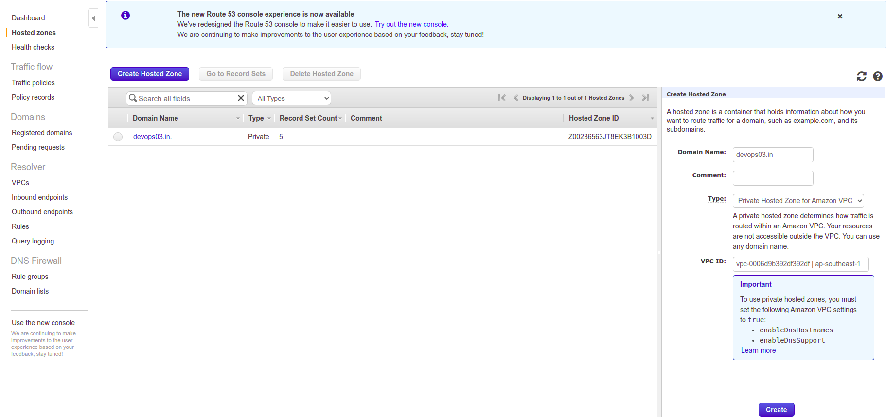

3.7) install kop cluster with 1 master,2 worker nodes, t2.micro , iam ubuntu 20 amd64
$ kops create cluster --zones=ap-southeast-1a --name=devops03.in --dns-zone=devops03.in --dns private --ssh-public-key=~/.ssh/id_rsa.pub --node-count=2 --node-size t2.micro --master-size t2.micro --master-zones=ap-southeast-1a –image=ami-01581ffba3821cdf3
$ kops update cluster --name devops03.in --yes –admin

3.8) delete cluster
$ export KOPS_STATE_STORE=s3://devops03.in
$ kops delete cluster devops03.in --yes

3.9) create password root
$ passwd root
Enter password

3.10) enable ssh by root user and password

$ nano /etc/ssh/sshd_conf
[ Find 2 lines under and edit , remember remove # of start line]
...
PermitRootLogin yes
PasswordAuthentication yes
...
[ Save and exit editor ]
$ systemctl restart sshd

3.11) check k8s cluster
$ kubectl get no
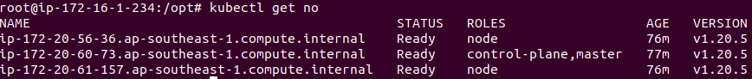

3.12) create 2 file deployment.yaml and service.yaml in /opt direction
$ cd /opt
$ nano deployment.yaml
apiVersion: apps/v1
kind: Deployment
metadata:
name: devops03
spec:
selector:
matchLabels:
app: devops03
replicas: 2
strategy:
rollingUpdate:
maxSurge: 1
maxUnavailable: 1
type: RollingUpdate
template:
metadata:
labels:
app: devops03
spec:
containers:
- image: soilangtu1993/devops03:v1.latest
name: test
imagePullPolicy: Always
ports:
- containerPort: 80
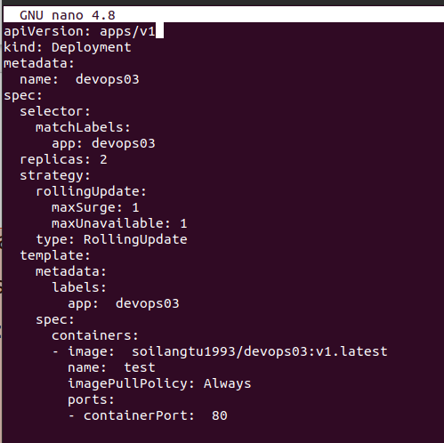

$ nano service.yaml
apiVersion: v1
kind: Service
metadata:
name: devops03
labels:
app: devops03
spec:
selector:
app: devops03
type: NodePort
ports:
- port: 8080
targetPort: 80
nodePort: 31200
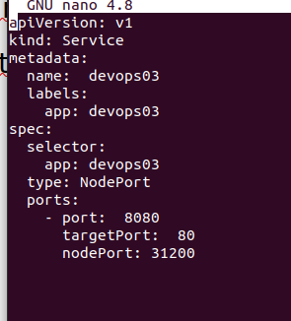

4) Ansible Server (172.16.1.3 - 151.20.x.x)
4.1) install ssh-keygen
$ ssh-keygen

4.2) copy public key to ansible server (allow ssh without asking password)
$ cd ~/.ssh/
$ cat id_rsa.pub
copy key characters to Controller server (~/.ssh/authorized_keys)
$ ssh root@controller-server-ip
$ exit

4.3) Create password root
$ passwd root
Enter Password

4.4) enable ssh by root user and password
$ nano /etc/ssh/sshd_conf
[ Find 2 lines under and edit , remember remove # of start line]
...
PermitRootLogin yes
PasswordAuthentication yes
...
[ Save and exit editor ]
$ systemctl restart sshd

4.5) create ansible.yaml
$ cd/opt
$ nano ansible.yaml
- hosts: all
become: true
tasks:
- name: delete old deployment
command: kubectl delete -f /opt/deployment.yaml
- name: delete old service
command: kubectl delete -f /opt/service.yaml
- name: create service
command: kubectl create -f /opt/service.yaml
- name: create dep
command: kubectl create -f /opt/deployment.yaml
$ nano /etc/ansible/hosts
[Controller]
172.16.1.1
$ save and exit file

4.6) login dockerhub
$ docker login
Enter username and pass

5) Jenkins Server (172.16.1.2 - 10.70.x.x)
5.1) install ssh-keygen
$ ssh-keygen

5.2) create workdir for devops03 project and clone project from github to folder
$ mkdir /var/lib/jenkins/workspace/devops03
$ chown –Rf jenkins:root /var/lib/jenkins/workspace
$ chown –Rf jenkins:root /var/lib/jenkins/workspace/devops03
$ cd /var/lib/jenkins/workspace/devops03
$ git clone https://github.com/trungvo11/devops03.git .

5.3) copy public key to ansible server (allow ssh without asking password)
$ cd ~/.ssh/
$ cat id_rsa.pub
[copy key characters to ansible server (~/.ssh/authorized_keys)]
$ ssh root@ansible-server-ip
$ exit

5.4) Create password root
$ passwd root
[Enter Password]

5.5) enable ssh by root user and password
$ nano /etc/ssh/sshd_conf
[ Find 2 lines under and edit , remember remove # of start line]
...
PermitRootLogin yes
PasswordAuthentication yes
...
[ Save and exit editor ]
$ systemctl restart sshd

5.6) clone file from github to local folder
$ su - jenkins # chuyển sang user jenkins
$ cd /var/lib/jenkins/workspace/devops03
$ git clone https://github.com/trungvo11/devops03.git . # . là đường dẫn hiện tại

5.7) install Publish Over SSH plugin on jenkins web-based
- Manage Jenkins -> Manage Plugins -> Available -> Publish Over SSH
5.8) config jenkins web
- Go to Dashboard -> Manage Jenkins -> Config System
- Find the line Publish over SSH
- Add SSH Server for Jenkins server and Ansible Server
+ Name: Jenkins
Hostname: 172.16.1.2
Username: root
Passphare/Password: 123
+ Name: Ansible
Hostname: 172.16.1.3
Username: root
Passphare/Password: 123

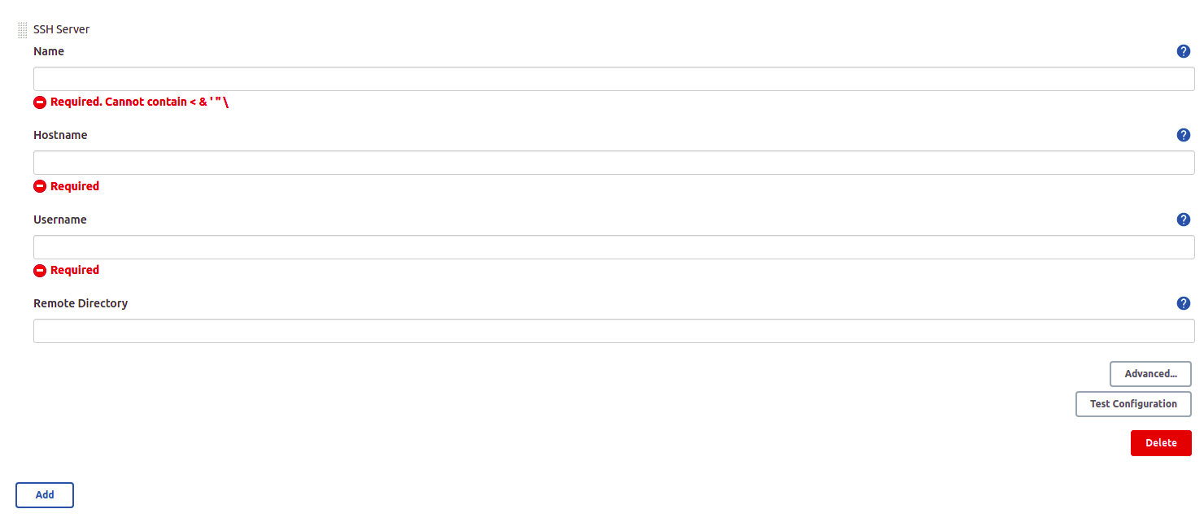

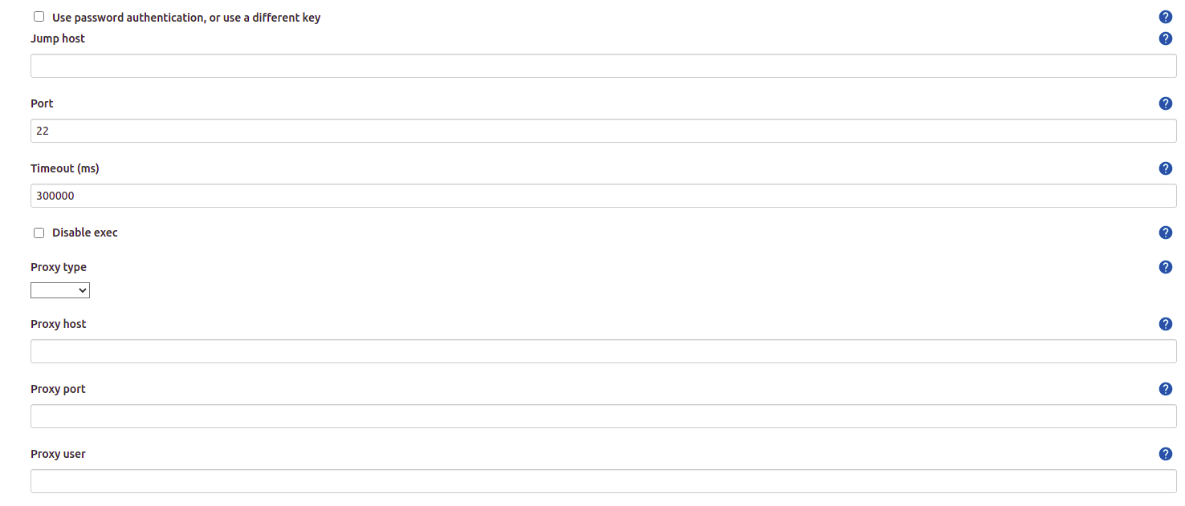
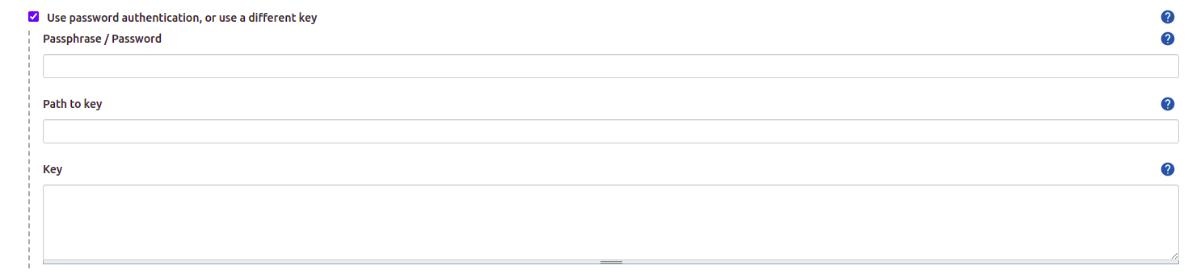

5.9) Create New Project
DASHBOARD -> New Item
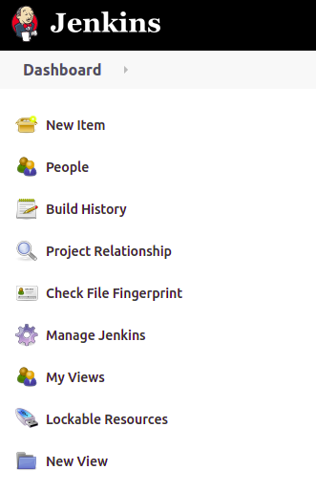
Enter an Item Name and choose Freestyle Project -> click OK
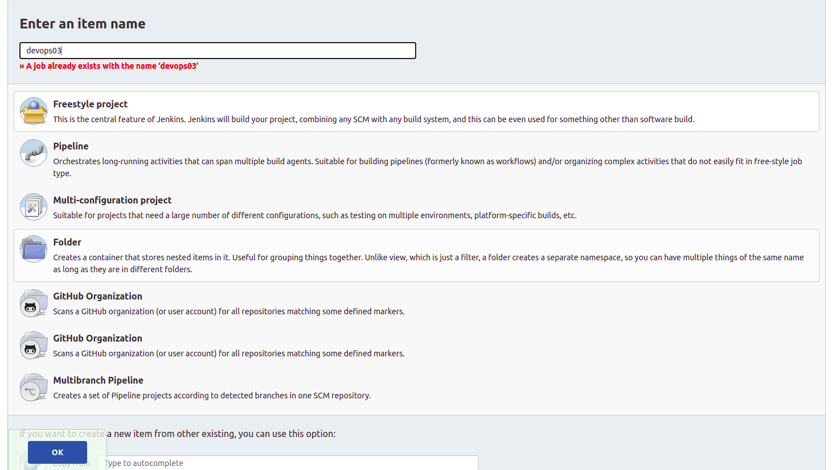
5.10) Devops03 Project’s Configure
Click Configure
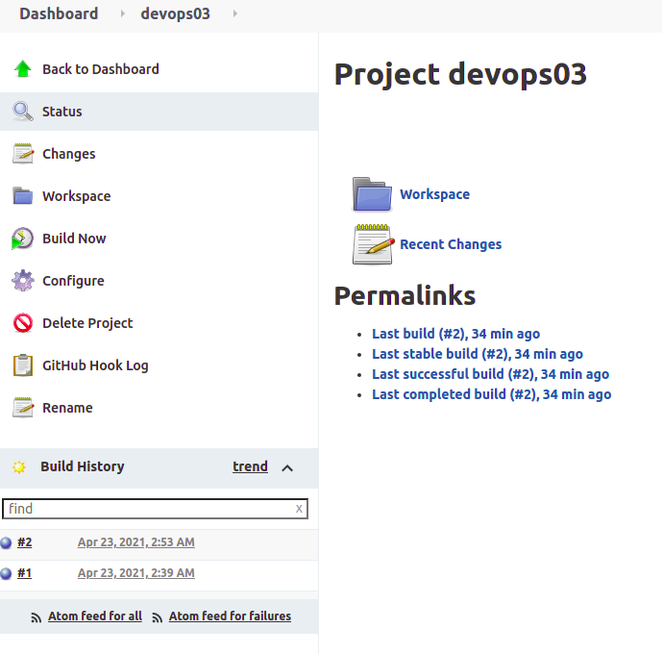
5.11)
create project name: devop03 in github first
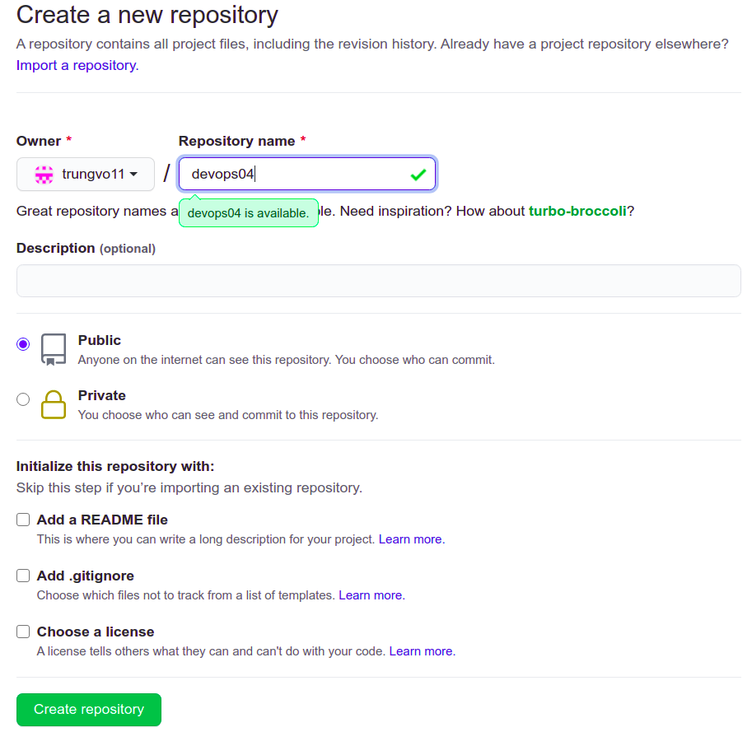
in Source Code Management : Copy link on github
And then, click Add -> Jenkins, enter account github on the page showing (trungvo11/password)
Branch Specifier: */main or */master (check on github project devops03)
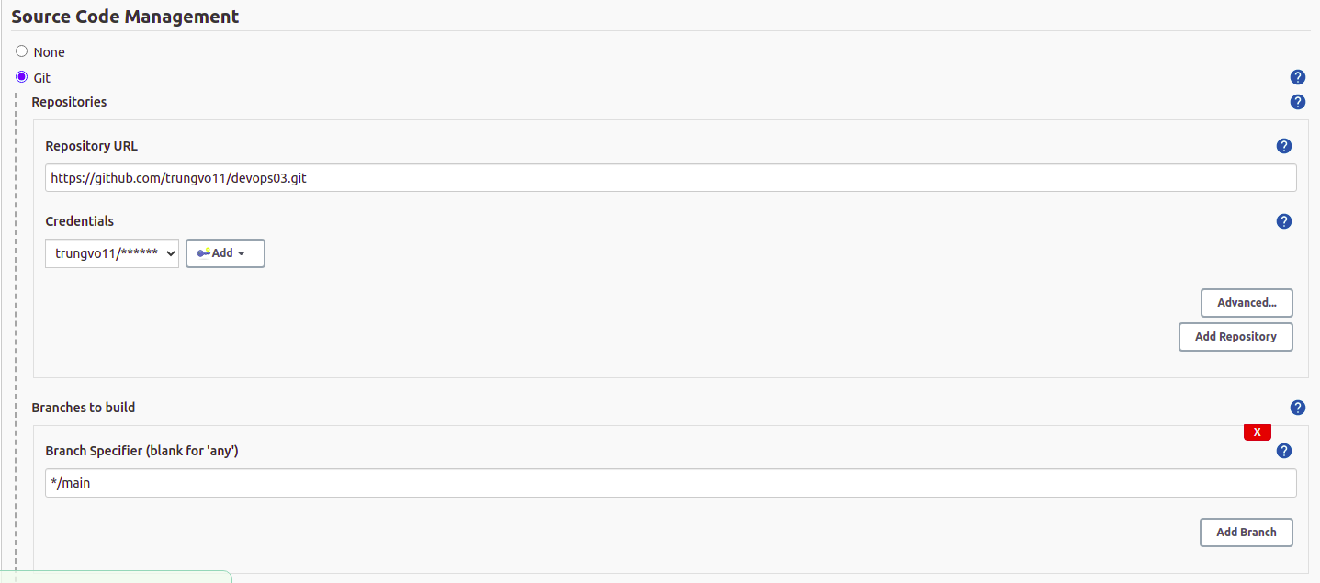
Build Triggers : click github hood trigger for GITScm polling
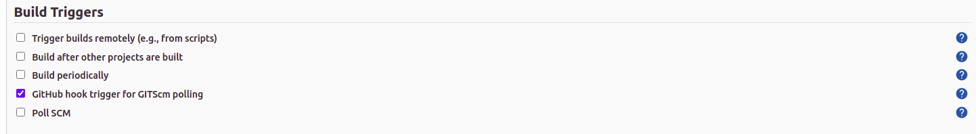
Scroll down to end of page , click Add build step -> Send files or execute commands over SSH
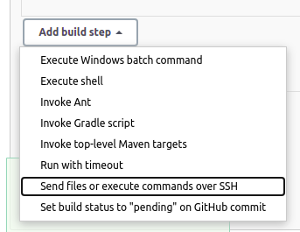
Config like 3 pictures below:
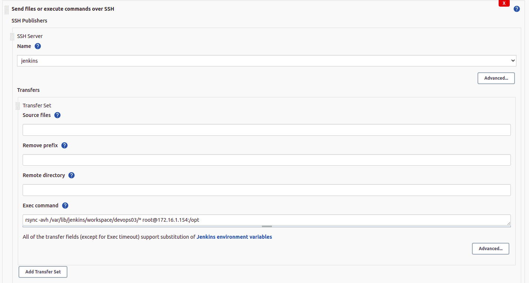
rsync -avh /var/lib/jenkins/workspace/devops03/* root@172.16.1.3:/opt # root@ansible-server:/opt
(lệnh này dùng để đồng bộ file từ folder devops03 của server jenkins sang đường dẫn/opt bên server ansible. File trong folder devops03 được clone từ github project devop03 xuống)
(github project's file = devops03 folder = 172.16.1.3:/opt)

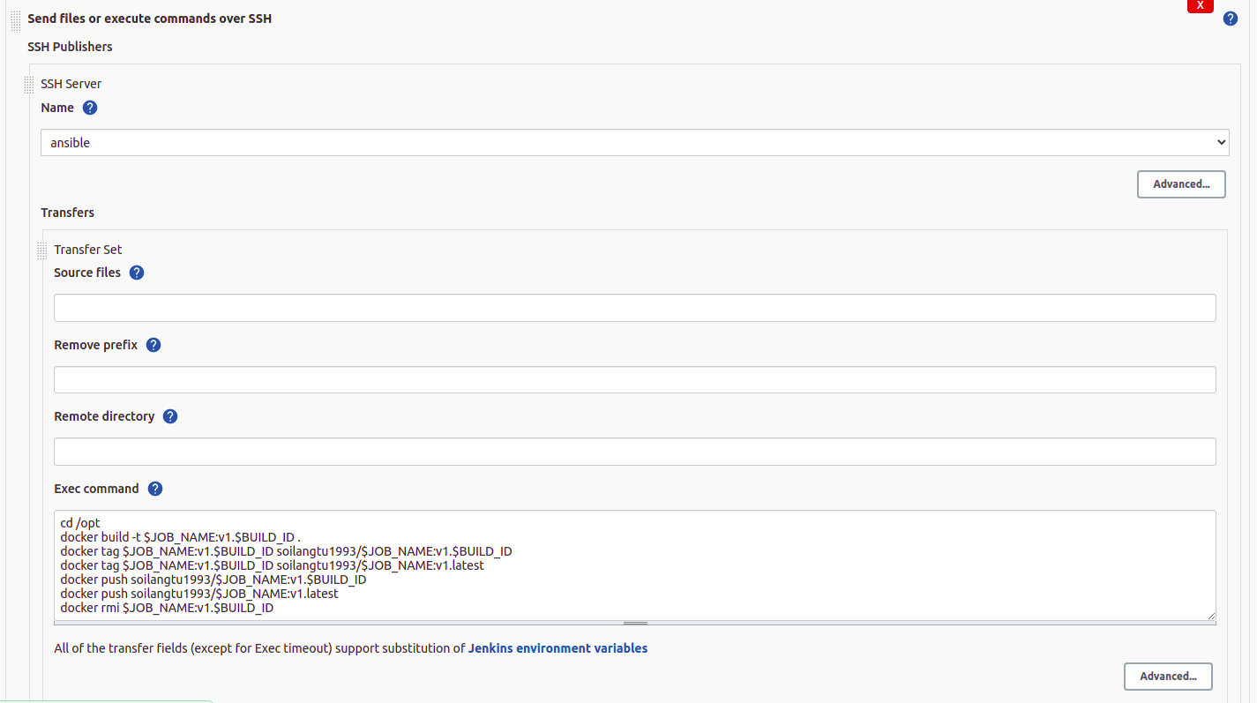
cd /opt
docker build -t $JOB_NAME:v1.$BUILD_ID .
docker tag $JOB_NAME:v1.$BUILD_ID soilangtu1993/$JOB_NAME:v1.$BUILD_ID
docker tag $JOB_NAME:v1.$BUILD_ID soilangtu1993/$JOB_NAME:v1.latest
docker push soilangtu1993/$JOB_NAME:v1.$BUILD_ID
docker push soilangtu1993/$JOB_NAME:v1.latest
docker rmi $JOB_NAME:v1.$BUILD_ID

# (docker build image dựa vào Dockerfile, sau đó đổi tên image dựa vào format của dockerhub, sau đó push image lên dockerhub, cuối cùng xóa image trên local)
# (Source Dockerfile nằm ở dưới, tạo file Dockerfile trên github)

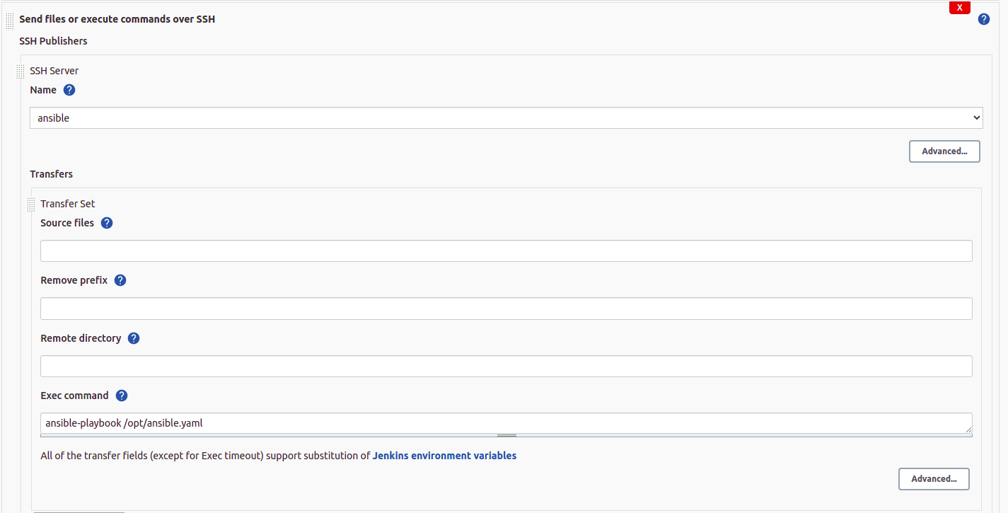Ansible-playbook /opt/ansible.yaml
# Ansible chạy file yaml, ssh vào Controller server và run theo config

5.12) get secret key no sync jenkins and github webhook
Go to Configure -> Under API Token -> click Add new Token -> generate -> copy Token (token will paste into github project setting)
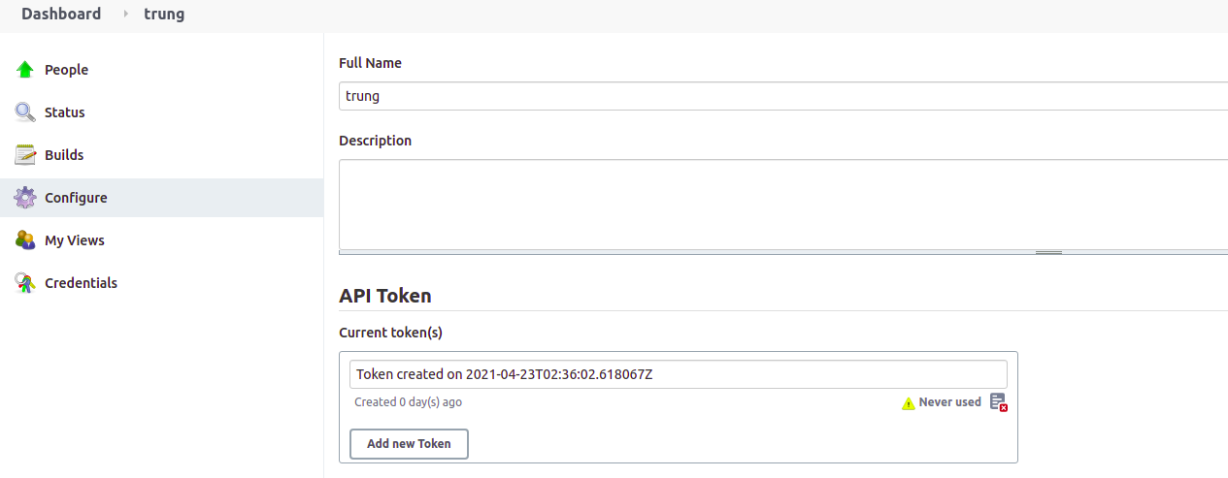
6) GITHUB Project devops 03
6.1) Config Webhooks
- Login to github, access to project devops03
- Go to Settings -> Webhooks -> Create new webhooks or edit if you already have one
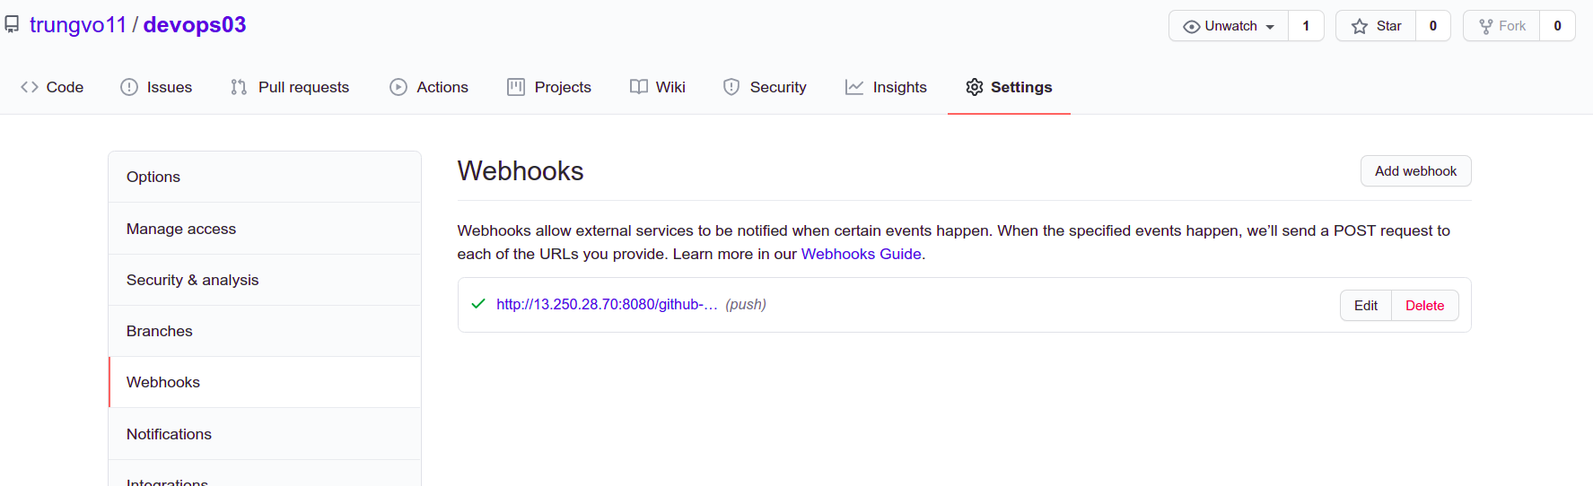
Payload URL: address for Jenkins Public IP web page
http://jenkinsweb:8080/github-webhook/
Secret Key : it’s Token key you generated in previous step.
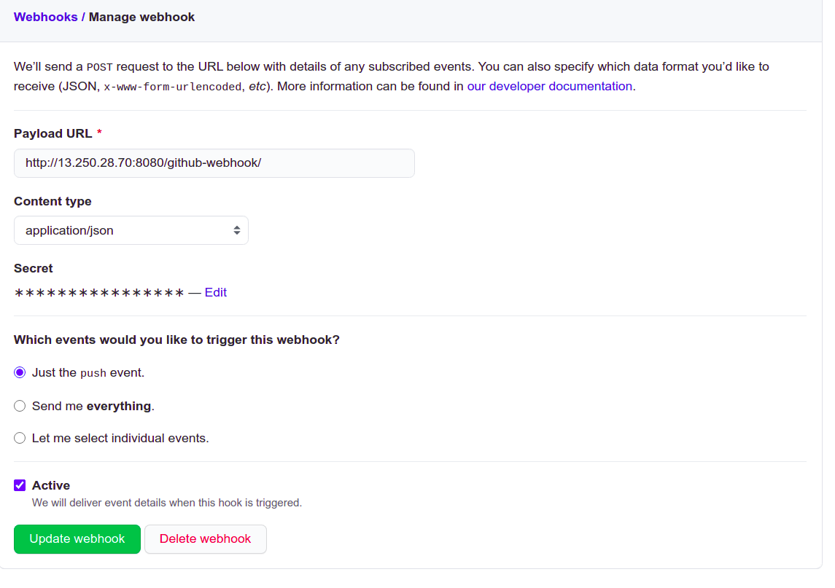
Click Update webhook .
6.2) Create Dockerfile in project
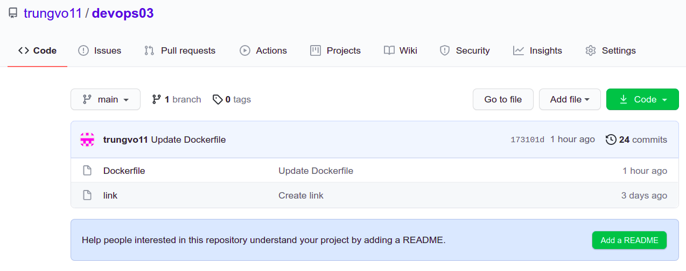Dockerfile source:
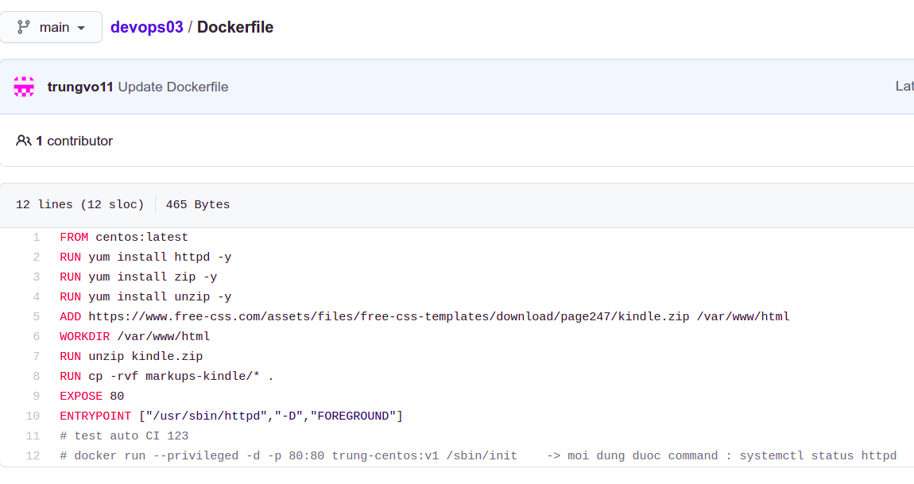
FROM centos:latest
RUN yum install httpd -y
RUN yum install zip -y
RUN yum install unzip -y
ADD https://www.free-css.com/assets/files/free-css-templates/download/page247/kindle.zip /var/www/html
WORKDIR /var/www/html
RUN unzip kindle.zip
RUN cp -rvf markups-kindle/* .
EXPOSE 80
ENTRYPOINT ["/usr/sbin/httpd","-D","FOREGROUND"]
# test auto CI 123
# docker run --privileged -d -p 80:80 trung-centos:v1 /sbin/init -> moi dung duoc command : systemctl status httpd

6.3) Test
- Click Build Now, check Build history (blue is correct, red is error, yellow is something not correct)
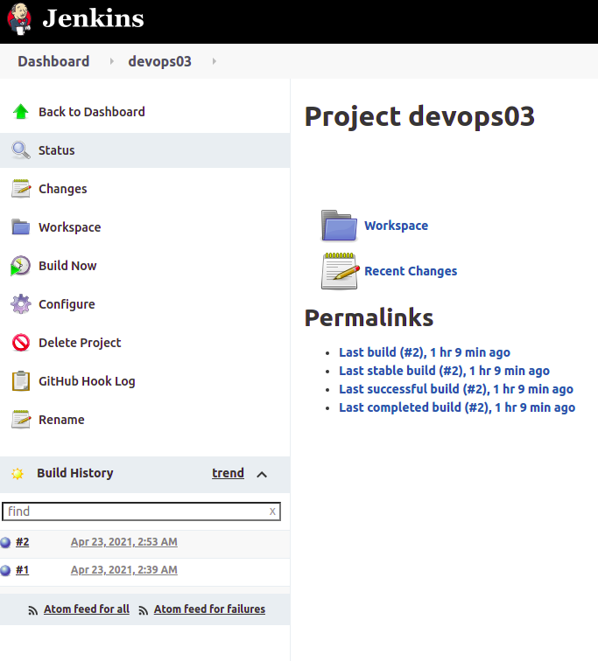
6.4) Check docker hub
# if you see your image in docker HUB, it’s nearly complete
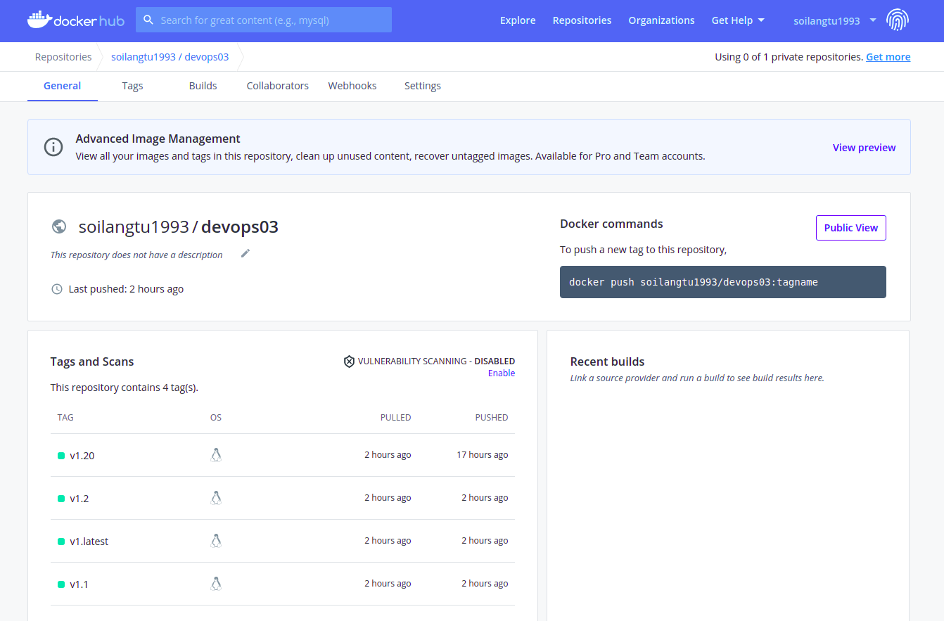
6.5) check k8s cluster
$ watch –n 1 kubectl get all –o wide
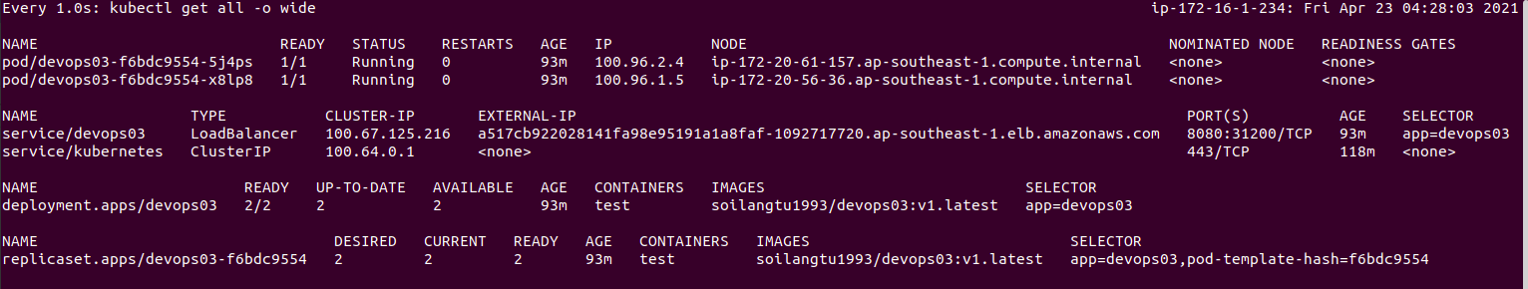
# if your cluster is the same with picture, it’s complete
6.6) open web page
First , allow traffic from k8s cluster to your IP address
+ Click to k8s NODE , in below, click security group (sg-0c ….)
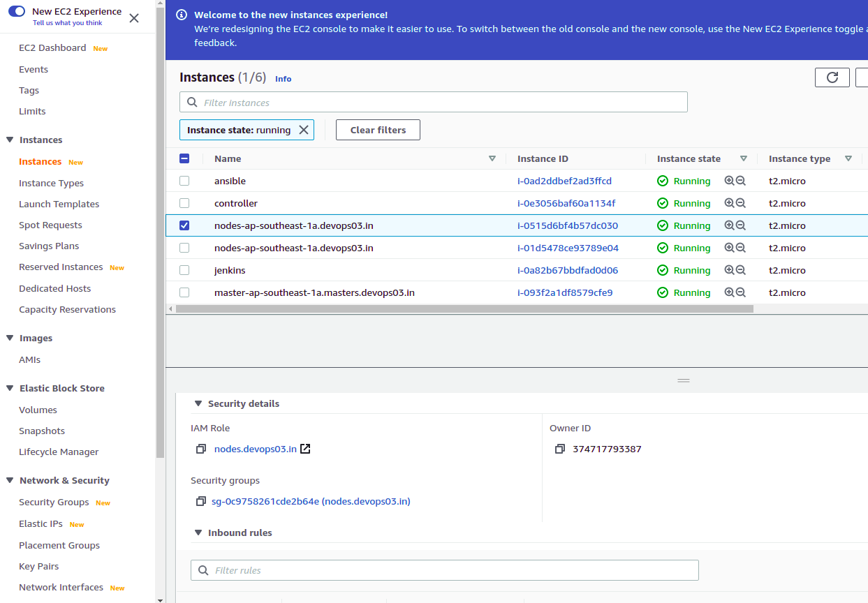
Click Edit Inbound rules
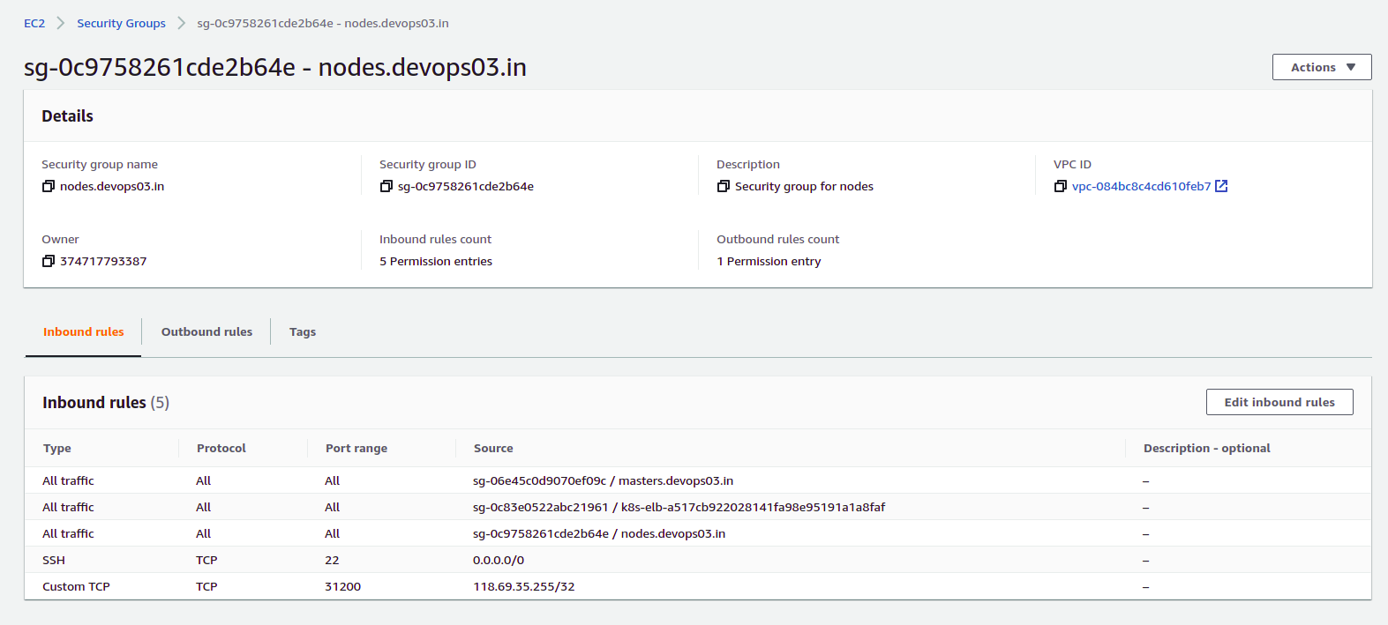
Add line to Inbound rules (the IP is your Public IP, or you can change to all)
Save . And check the web
+ Node public IP is 52.221.210.84 (we have 2 Node, so you can choose any node. The other Node IP is 13.212.176.173)
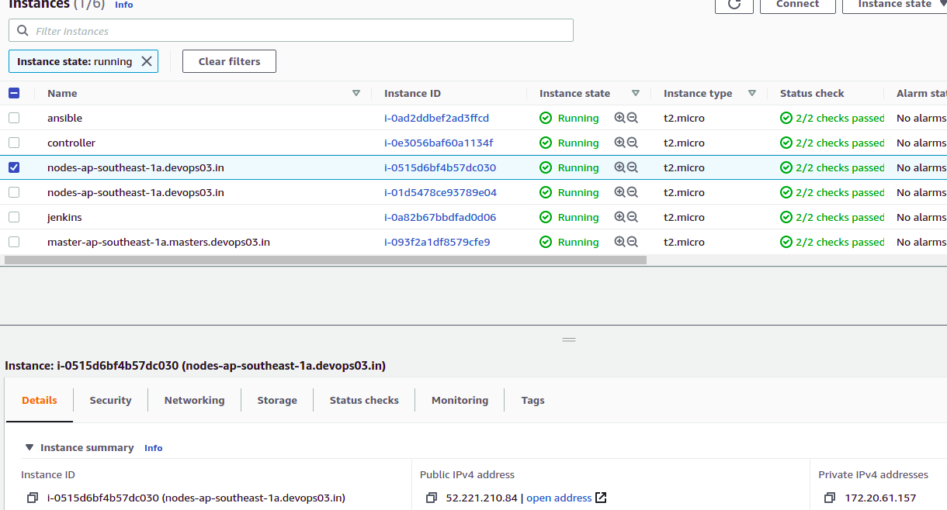
+ open web : 13.212.176.173:31200
# k8s service port 31200 : map port 8080 from pod to internet port 31200
# port 8080 map port 80 from container to pod port

Container expose port 80 -> pod 8080 -> internet 31200
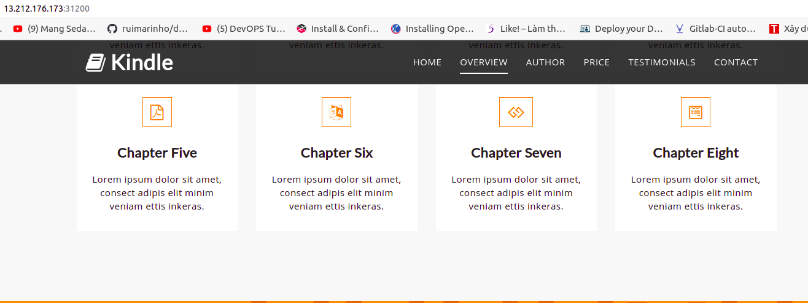
DONE

